INMAIL
TEMPLATE

Homepage Inbox Message Sample
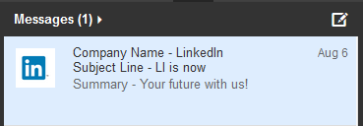

1
2
4

Talent Direct Message Sample
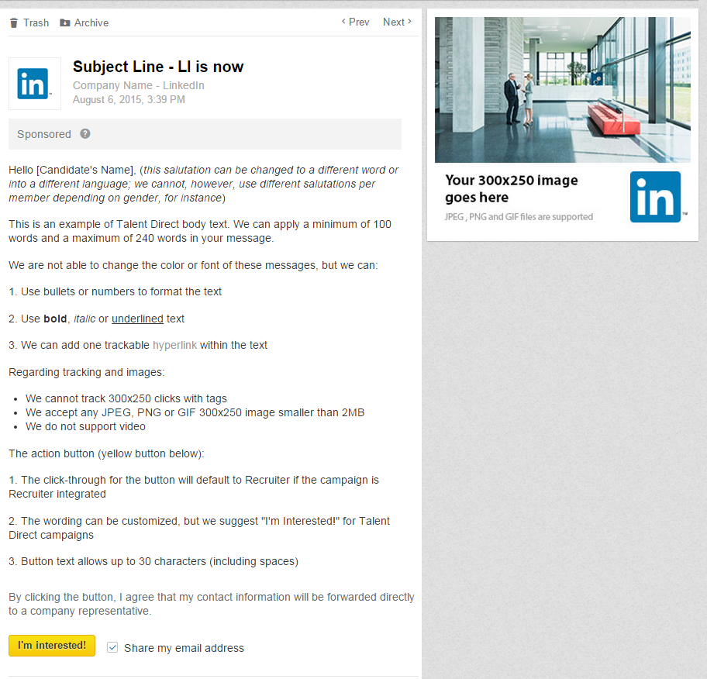
INMAIL ASSETS: Please Complete ALL Fields
2
7
6
5
1
4

Homepage Inbox Assets
1
Company Name
Specify sender - 30 characters maximum, including spaces

Subject Line
Tagline - 60 characters maximum, including spaces
2
3
4
LinkedIn Company ID or Company Page URL
Provide LinkedIn Company ID or URL so your logo can be used for the icon box

Talent Direct Message Assets
5
InMail Salutation String
One word: Hi, Dear, Hola, Beste, etc.
6
InMail Body Text
Simple, attention-grabbing messages work best - Minimum 100 words; Maximum 1500 characters
6

*3 link max for clickable hyperlinks*
Action Button (yellow)  Text default is “I’m Interested!”; maximum 20 characters, including spaces  7  7 | “I’m Interested!”
Action Button URL  The click-through URL for the Action Button - not available for Recruiter integrated campaigns (including Lead Capture Landing Pages) | Responses flow into Recruiter

Recruiter Integrated Assets

Recruiter Account Name/Contract ID
You may also provide the link to the profile of the person who is going to manage the Recruiter folder

Test Drop Recipients
For the test drop, please provide up to five member IDs/profile links to employees of your organization

Recruiter Campaign Folder Name
The default name will be the same as the subject line of the message. If you prefer to have a different name, please specify - limit of 45 characters

AD SPECS: Provide Image Separately from Template Doc

300x250 Click-Through URL
Destination link for your image – not available for Recruiter integrated campaigns (including Lead Capture Landing Pages)

Dimensions: 300x250
File Types: GIF, JPG, PNG
Size Limit: 2MB
*If no image is provided, another (unrelated) ad will appear in its place

Tips
- We recommend keeping the message direct, concise and conversational.

- Direct: Members receive InMail for many reasons. Be explicit that this message is regarding a career opportunity.

- Concise: 2-3 brief paragraphs is about as much as someone is going to read. Provide an overview of the company, the opportunity, and why the member should be interested.

- Conversational: Try to avoid a message that reads like a press release. Since we're reaching someone in their inbox and addressing them by name, a slightly more casual tone is appropriate.

